
The School of Technology
BSc (Hons) in Software Engineering
(Batch - 08)
Software Architecture and Design
4CS017
W.Udara Nethmi (2501573)
Module Leader: Ms. Suranji Nadeeshani
Submission Date: 06/11/2024

This weather app allows you to know the Colombo weather. This will enable you to know the updated weather details. Open weather map was used to find the weather of the location. It is basically created by HTML/ CSS ,Java Script and using API Key.
HTML Structure : Creating a basic web page with input fields for the location for displaying weather data. CSS Styling : Styling the app Java Script Integration : Implementing the logic to fetch weather data from the open weather map API using java script. API Integration : The open weather map API was used to provide real time weather information. An API Key was used to authenticate requests and fetch data. While creating the weather app, I encountered several challenges, including a lack of time, errors in the code, and a limited understanding of JavaScript. Additionally, the API key wasn’t working properly, and the overall code wasn’t function as expected, making the development process more difficult.

The weather app I developed has strengths and weaknesses. Its main strength is the use of the Open weather map API, which provides accurate weather data for Colombo. The app displays temperature and description in a user- friendly way, with a sky- themed background enhancing its visual appeal. Error handling through a catch block ensures users are informed if data fetching fails. Simple HTML and CSS keep the app lightweight and easy to navigate.
However, the app has limitations. It currently only shows weather for Colombo, but adding features like a search bar, hourly forecasts could improve it. The design lacks full responsiveness across devices. Overall, the app could benefit from more features, better responsiveness, and increased interactivity.

The codes are given below.
This is my HTML code
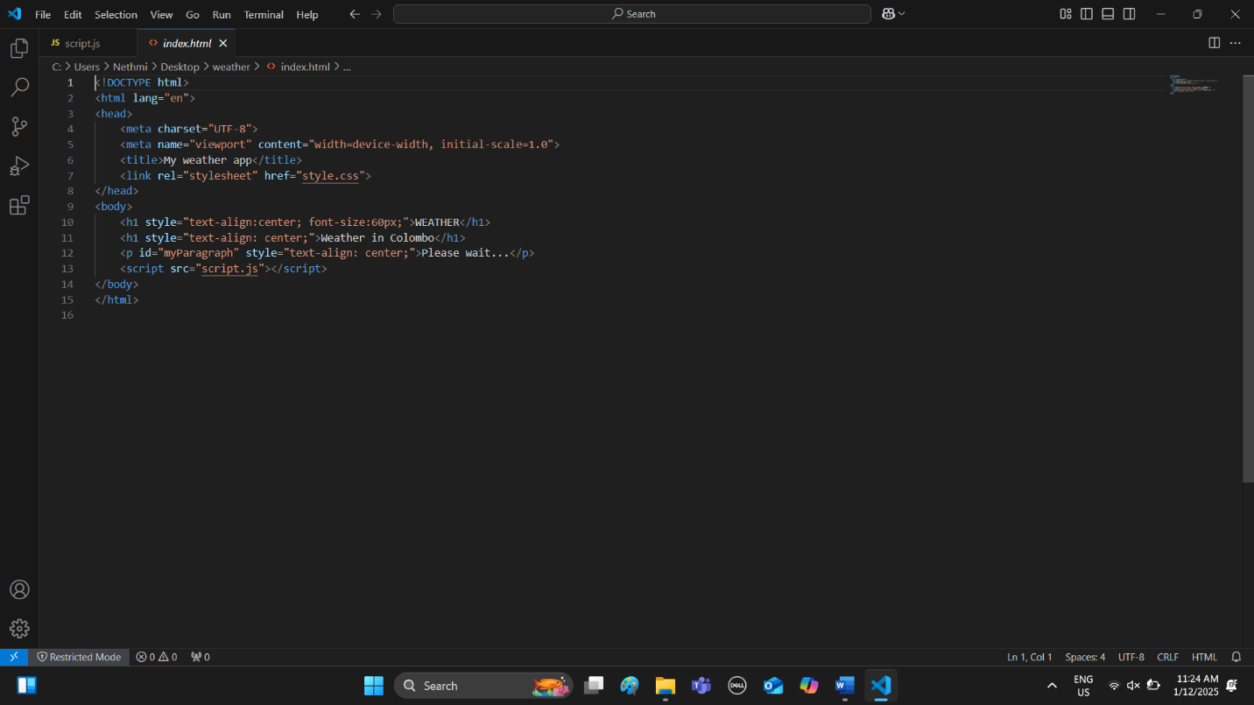
This is my CSS Code
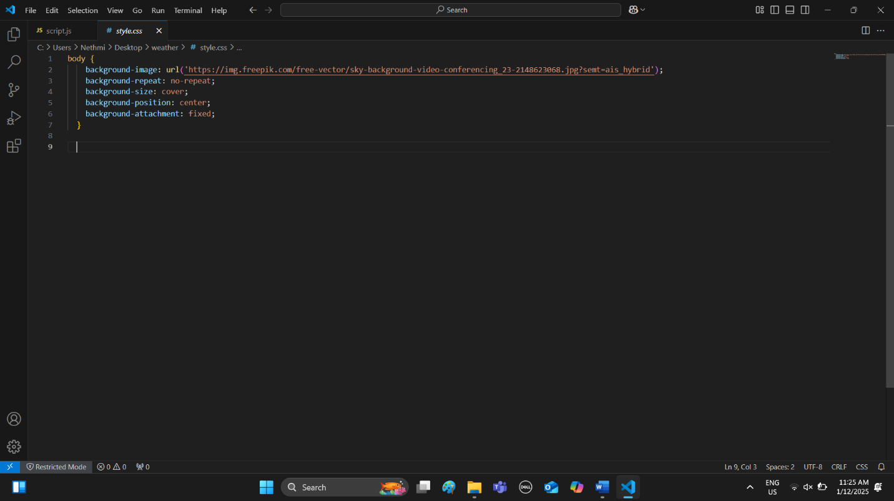
This is my Java Script Code
